**Ex. No.: 12**

**Date: 07.05.2024**

**CUSTOMIZATION OF LINUX KERNEL**

**Aim:**

To download the vanilla Linux kernel from repository and customize to our requirements.

**Customization Steps:**

1. Download the vanilla kernel from www.kernel.org

2. Switch to root user using the command

[root@localhost os]#su

3. Use dnf to install kernel-devel package

[root@localhost os]#dnf install kernel-devel

4. Install gcc development tools

[root@localhost os]#dnf group install "Development Tools"

5. Install additional software packages

[root@localhost os]#dnf install ncurses-devel bison flex

elfutils-libelf-devel openssl-devel

6. Copy the downloaded kernel source to /usr/src/kernels

[root@localhost os]#cp linux-5.0.0.tar.xz /usr/src/kernels

7. Go to kernel source directory

[root@localhost os]#cd /usr/src/kernels

8. Extract the downloaded vanilla kernel

[root@localhost os]#unxz linux-5.0.2.tar.xz

[root@localhost os]#tar xvf linux-5.0.2.tar

9. Remove all old configuration files

[root@localhost os]#make mrproper

10.Configure the Kernel

[root@localhost os]#make menuconfig

11.Build the Kernel(For faster build use –j 2 option)

[root@localhost os]#make all

12.Remove all temporary files

[root@localhost os]#make clean

13.Install Kernel and its modules

[root@localhost os]#make modules_install

[root@localhost os]#make install

14.Reboot the system

**Output:**

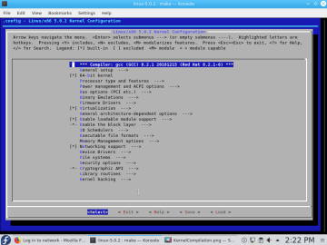71

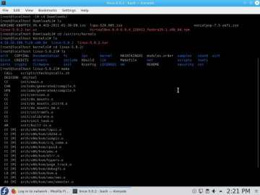

**Result:**

Customization of linux kernel has been executed successfully.